Test Case Id: 01 |  | Test Purpose: Enable visitors to take part in a quiz
Environment: Written in Java using JDK 8 v121 running in Windows 10
Preconditions: The quiz preferences must be set up by the engagement team
Test Case Steps: 6
Step No | Procedure |  |  | Response | Pass/Fail
1 | Start the quiz. |  |  | The quiz user interface is displayed which shows the question and the multiple-choice answers as buttons. Along with the restart and quit buttons. | Pass
2 | From the 4 answer buttons, select the button which has the right answer. |  |  | 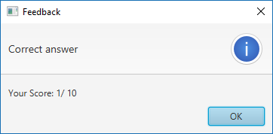  The user is displayed with a pop showing they answered correctly and also an “OK” button which allows them to make it disappear. Also, a running score is displayed | Pass
3 | (Alternate flow of step: 2)  From the 4 answer buttons, select the button which has the wrong answer. |  |  | 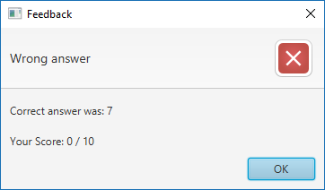  The user is displayed with a popup showing they answered wrongly and also an “OK” button which allows them to make the popup disappear. The correct answer & a running score is displayed. | Pass
4 | For steps 2 and 3, in the pop window click the “OK” button. |  |  | Returns the user to the quiz for both steps. And display the next question along with its respective answers. | Pass
5 | Answer ALL the questions of the quiz correctly or in-correctly. |  |  | 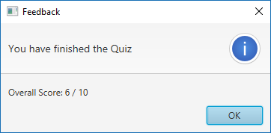  The quiz allows all 10 questions to be answered through multiple choices.  After the last question is reached a pop window appears showing how much the user scored. | Pass
6 | (Alternative flow to step 5)  Click the quit button |  |  | The quiz window closes, and the user is taken to the very beginning window which is the Quiz Launcher. | Pass
Comments:
Related Tests:
Author: Rayner Da Cruz |  |  | Checker: Spyros Lontos

Interface Used:

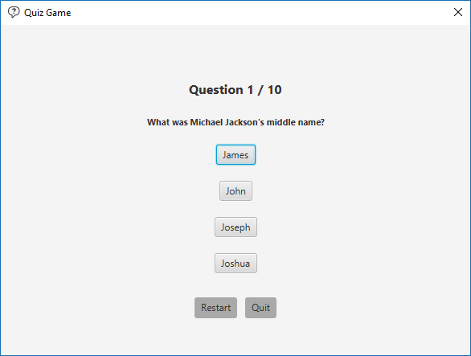

Test Case Id: 02 |  | Test Purpose: Allow the COMSC engagement team to amend current questions
Environment: Program written in Java 8
Preconditions: “Amend Question” button pressed in “Settings” Menu
Test Case Steps: 5
Step No | Procedure |  |  | Response | Pass/Fail
1 | Press “Edit” button |  |  | Makes table cells Editable | Pass
2 | Double click a table cell to amend its contents. |  |  | 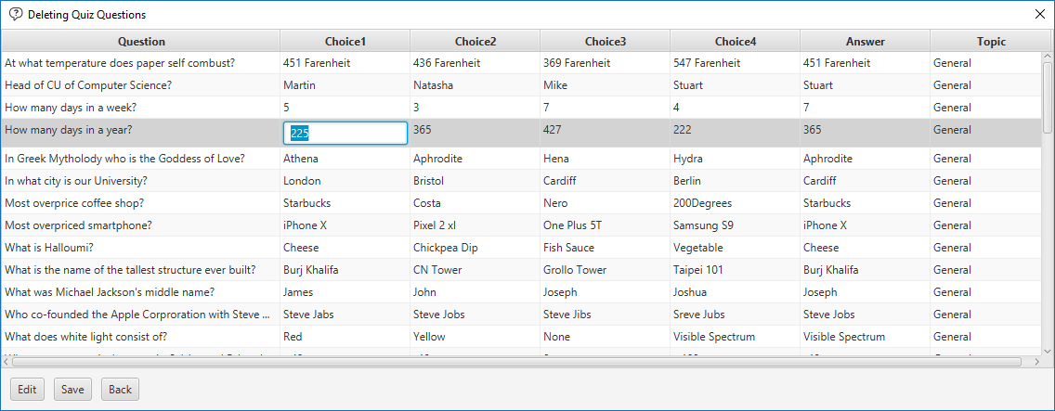  Cell text can be edited | Pass
3 | Change cell content |  |  | 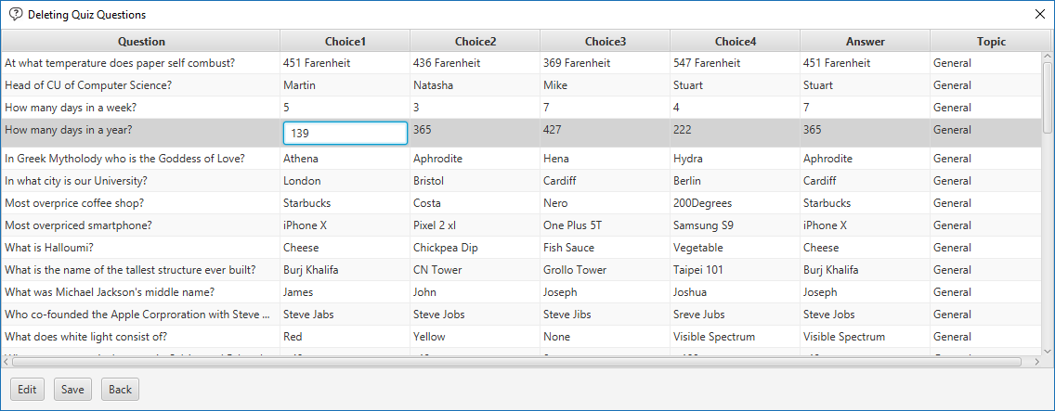  Cell selected contains new content | Pass
4 | Press “Enter” to store new content |  |  | 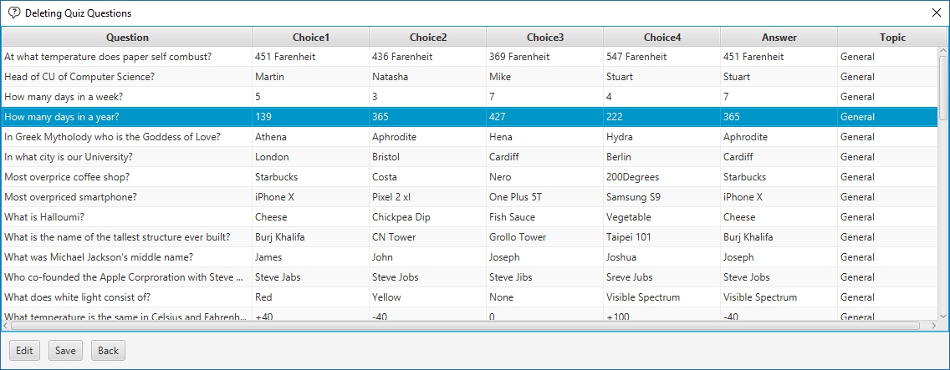  Cell content is updated
5 | Press “Save” button to store changes in the “listQuestions.csv” file. |  |  | 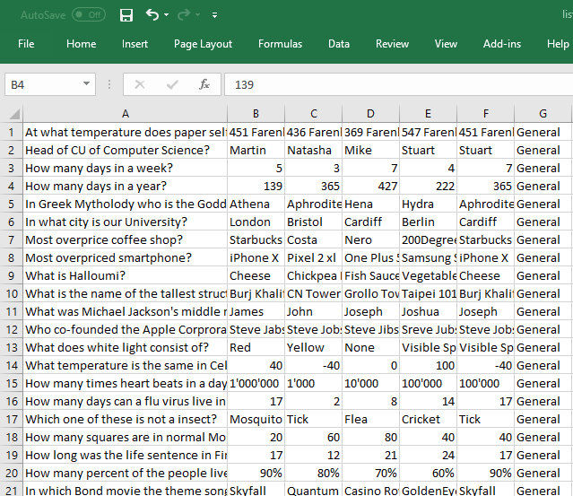  “listQuestions.csv” file is updated with the changes | Pass
Comments: If the user changes the cell content but doesn’t press the “Save” button the changes will not be made in the “listQuestions.csv” file, thus changes will not be shown while taking the Quiz.
Related Tests:
Author: Spyros Lontos |  |  | Checker: Adriano Sole

Spyros Lontos
C1722325

Interface Used:

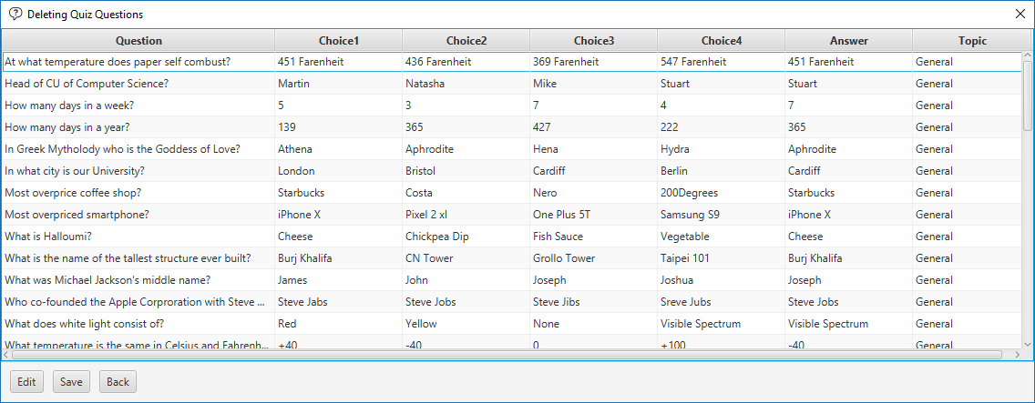

Test Case Id: 03 |  | Test Purpose: Allow the COMSC engagement team to obtain statistics from the users taking the quiz.
Environment: Program written in Java 8
Preconditions: Event information such as “Year Group” and “Schools Attending” have been entered and the quiz has been played a few times so that the statistics can be checked.
Test Case Steps: 2
Step No | Procedure |  |  | Response | Pass/Fail
1 | Press “Get Average” button |  |  | 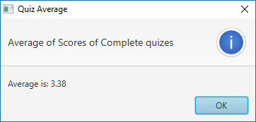  Shows a pop-up box with the average marks that users acquired during the event. | Pass
2 | Press “OK” button |  |  | The pop-up box closes and a “Settings” menu is presented. | Pass
Comments:
Related Tests:
Author: Ryan Harris |  |  | Checker: Alfie Potter

Ryan Harris
C1739845

Interface Used:

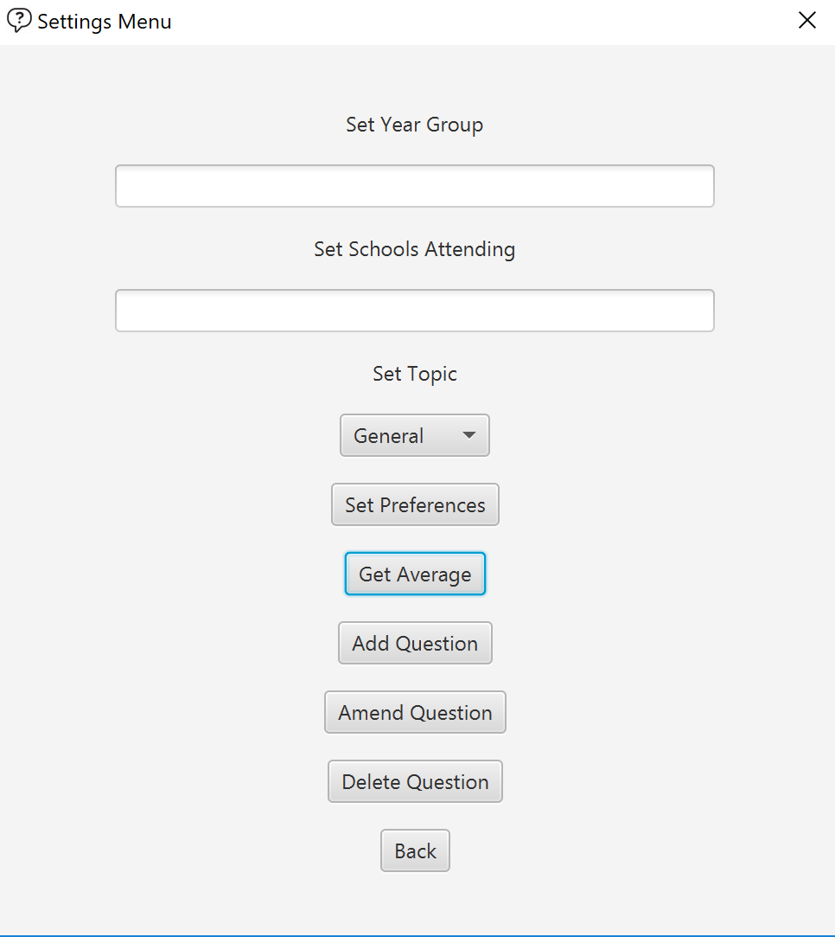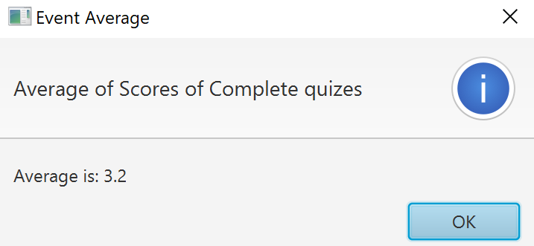

Test Case Id: 04 |  | Test Purpose: Testing entering information about schools attending
Environment: Program written in Java 8
Preconditions: Logged in successfully to admin settings
Test Case Steps: 4
Step No | Procedure |  |  | Response | Pass/Fail
1 | Enter “Year 3” into the Set Year Group field |  |  | Set Year Group field now contains the year group | Pass
2 | Enter “St Andrews” in the Set Schools Attending field |  |  | Set Schools Attending field now contains the schools name | Pass
3 | Select “General” using the drop-down menu |  |  | Set Topic drop-down box has “General” selected | Pass
4 | Press the Set Preferences button to save the details to file |  |  | The first two fields are cleared to show that data has been added | Pass
Comments: in the case that the user presses the Set Preferences button without the first 2 steps done they will be presented with an error screen.
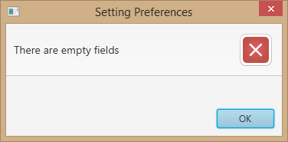
Related Tests: Set topic
Author: Adriano Sole |  |  | Checker: Rayner Da Cruz
Adriano Sole C1731426
Interface used:
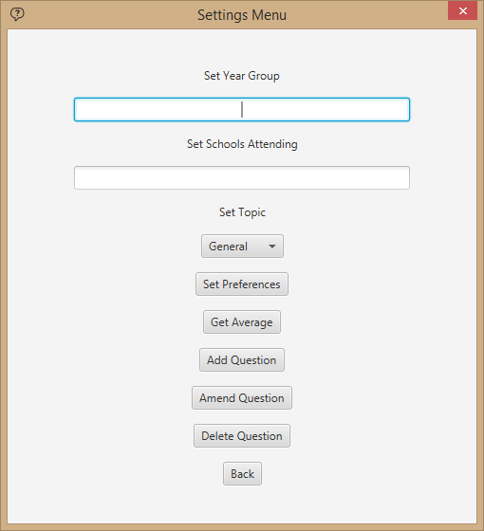

Test Case Id: 05 |  | Test Purpose: To test selecting a specific topic for the quiz being taken
Environment: Program written in Java 8
Preconditions: Logged in successfully to admin settings
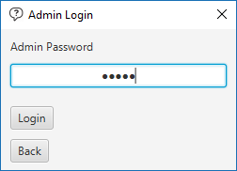
Test Case Steps: 2
Step No | Procedure |  |  | Response | Pass/Fail
1 | Click on the drop-down menu under Set Topic |  |  | The list of topics will show on the drop-down menu | Pass
2 | Select the topic you want the quiz to be based about |  |  | The box will have your selected topic and the quiz will only ask questions based on that topic | Pass
Comments: The default topic is GENERAL. So, if the user doesn’t change anything the quiz is automatically set to ask the GENERAL topic questions.
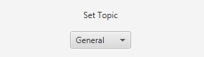
Related Tests: Attending Schools Information being entered
Author: Alfie Potter |  |  | Checker: Ryan Harris
Alfie Potter C1727851

Interface used:

Test Case Id: 06 |  | Test Purpose: Picking random questions for each quiz
Environment: Written in Java using JDK 1.8 v121 running in Windows 10 Build 16299
Preconditions: The quiz preferences must be set up by the engagement team
Test Case Steps: 2
Step No | Procedure |  | Response | Pass/Fail
1 | Start the quiz. |  | The quiz user interface is displayed which shows the question and the multiple-choice answers as buttons. Along with the restart and quit buttons. | Pass
2 | Click on the restart button |  | Loads a new set of questions in random order | Pass
Comments:
Related Tests:
Author: Reem Alotaibi |  |  | Checker: Rayner Da Cruz

